Professoressa Russo
Elementary Italian I
ANNO SCOLASTICO 2019-2020
rrusso@manasquanboe.org
http://www.manasquanschools.org/Domain/429


Ciao e benvenuti alla classe della Professoressa Russo!
Course description:
Elementary Italian I is a 10-week introduction to the basics of Italian language and culture. It focuses on the development of oral and written communication skills. Students will learn elementary grammatical structures and seek insight into many elements of the Italian culture. They will develop and perfect skills through discussion, cultural readings and informal presentations. Time will be spent working as a class, in groups and individually. Students will be presented with situations typical to traveling and living in Italy. Through these assessments, they will develop skills in a linguistic atmosphere, both creatively and effectively. Additionally, they will acquire a basic understanding of the structure of the language and apply this through interpretation and various prompts.

Class materials: To be brought EVERDAY to class!
- A blue/black pen or pencil
- 1” inch 3-ring binder with the following sections:
- Fate adesso! [Do Now]
- Appunti [Notes]
- Compiti [Homework]
- Folder
- Tablet=FULLY CHARGED!

Grading:
- Homework: ALL HW postings will be on Canvas by 3PM. Homework is expected to be completed ON TIME for full credit. For homework not turned in on time students will receive a late grade.
- If you are absent you are required to show me your homework upon your return to class in order to receive credit. **If an assignment is sent in electronically it is important to come check with me to make sure that I received it!

- Classwork: Upon entering class, complete the “Fate Adesso” [warm-up activity]. This counts as part of your classwork/participation grade!

- Participation: Your participation in this class is ENCOURAGED and REQUIRED in order to guarantee your success in this course! ☺ You have the opportunity to earn a total of 14 participation points for the marking period. You will have access to the scoring rubric which is posted on Canvas.

- Technology: Please be sure that your Canvas page is properly synced to our course, Italian Grade 8 You will need your tablet charged every day for class.

- Assessments (Tests/Quizzes/Presentations): Can be written or oral. These assessments will be a cumulative review of the material presented in class. You will be assessed in the following categories:

For example…
  - Interpretive mode: Reading a short story or listening to a song and predicting what the singer’s intentions were while writing it.
  - Interpersonal mode: Having a conversation in Italian or writing a simple email back and forth with a friend. “Two-way” communication.
  - Presentational mode: Presenting a cultural based piece or ad for a target audience.

Your marking period grade will be determined by:
Total points earned

Total possible points
Cheating:

- Is UNACCEPTABLE on any type of assignment OR assessment.
- A zero will be given to all parties involved & the incident will be reported to an administrator who will make a phone call home. A record will be kept of the incident on Genesis.
- Cheating includes: talking during a test/quiz/assessment, looking at someone’s paper during a test/quiz/assessment, copying homework, plagiarizing or using an online translator, cheat sheets, writing on desks or text messaging.

Use of online dictionaries/translators:
Online translators ARE NOT permitted! This will result in a 0 for the assignment. Google Translate is NOT your friend! I encourage you to use www.wordreference.com as a reference for an online dictionary if you do not have an Italian dictionary at home! ☺
Tardiness:

If you are late to class, please do not disrupt the class. Any student entering late to the classroom must have a pass from another teacher or staff member. Excessive lateness/entering without a pass will result in lunch or afterschool detention.

For missed work:

- It is your responsibility to find out what you missed when you were absent; this includes checking your grades online through Genesis. Please speak with me before class, not during class! ☺

- Missed work should be made up in a timely fashion. Nota bene: A zero will be put in the gradebook until the test/quiz/assignment has been made up. Any missing or outstanding assessments not made up prior to the end of the marking period will remain a zero. No make ups will be given during school hours.

Cell Phone/Tablet Policy:

Any audio/video recording without my permission will be subject to the consequences in the Manasquan BOE policy #5516.

Cell phones WILL BE prohibited during instruction. They are to be kept in your locker, please DO NOT bring them to class! We will be using the school tablets as our primary source of technology. Any audio/video recording without my permission will be subject to the consequences in the Manasquan BOE policy #5516.

Please make sure that you bring your tablet EVERYDAY and that it is fully charged! ☺
**Nota bene: Please be sure to always come to class with your tablet charged! Note that this counts toward your preparedness in class and will affect your participation grade.
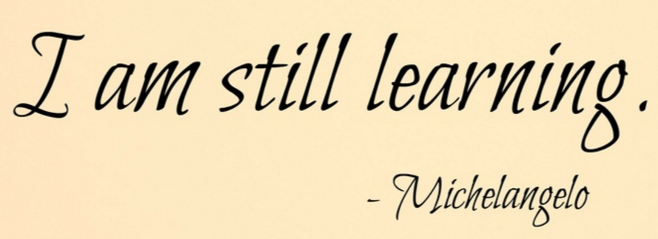
**Learning a world language requires practice and active listening. I encourage all students to speak as much Italian as possible. Take risks and participate as much as possible!
Le regole della classe (Classroom rules):
 This is one of Prof.ssa Russo’s most important rules in Italian class! As a member of our classroom community, it is YOUR RESPONSIBILITY to create and enrich a positive learning environment by showing respect in the following ways:
- Be in your seat when the 2nd bell rings ☺
- La tessera → You are required to wear your ID badge at all times.

- Arrive to class with all required materials.
- Begin your “Fate adesso” (Do Now) and have your homework ready to be checked.
- Listen, do not interrupt the teacher or another student when they are talking. Raise your hand to contribute to class discussion or ask a question.
- Treat everyone with respect and dignity. No swearing, teasing, or bullying. Inappropriate behavior/language WILL NOT BE TOLERATED.

- Take care of class property by using it correctly, and returning it to proper location after use.

- Participate actively in class activities!
- We will be working from bell to bell. Please stay seated until Prof.ssa Russo dismisses you.

- The use of cellphones/smartphones, mp3 players, headphones and other electronic devices that DO NOT pertain to the lesson is prohibited.

- Follow all classroom procedures to ensure a productive learning environment.

- Mantieni la calma e parla in italiano! (Keep calm and speak Italian!) ☺ You will be evaluated on your speaking skills through participation and daily activities.

**As the marking period progresses, please be aware that certain policies might change. We will discuss any changes in class.

Le conseguenze (Consequences):
***FAILURE TO FOLLOW THESE RULES WILL RESULT IN DISCIPLINARY ACTION.***
- Warning (Stay after class, parents/guardian will be contacted).
- Teacher detention (before/after school/during lunch).
- A referral slip will be written up and handed in to the office of the vice principal.

Contacting Professoressa Russo 
Remember that I am here to help you succeed in class and have a wonderful experience learning Italian! ☺
- I will be available in room 307 before and after school for extra help & by appointment.
- If you have a question or need assistance in regards to a particular assignment you can contact me via email: rrusso@manasquanboe.org

Dear Parents/Guardians,
Ciao a tutti! I’m looking forward to a successful and productive year with your child this marking period! It is extremely important that you read over the enclosed information with your child.
If you have any questions, please do not hesitate to contact me at rrusso@manasquanboe.org or
(732) 528-8820 ext. 1845
Please sign this form to indicate your compliance with the stated rules and regulations of the class. Students, please keep the remaining portion in your binder.
Sincerely,
Rosa Russo
--------------------------------------------------------------------------------------------------------------------------------------------------------------
Please complete and return this portion by Friday, September 6th, 2019.
__________________________________ ___________________________________
Student signature Parent/Guardian signature

Parent/Guardian Name: ________________________________________________________________
Parent signature: _______________________________________________________________________
- Daytime phone number: ____________________________________
- Parent/Guardian cell phone number: __________________________________________
- Preferred e-mail address of parent/guardian: ________________________________
**Please check off the most convenient way(s) in which you would like to be contacted.

